1. a. Give reason to explain why ClF₃ exists but FCl₃ does not exist.
b. Explain why ozone is thermodynamically less stable than oxygen.
2. Give reason for:
a. Though nitrogen exhibits +5 oxidation states, it does not form pentahalide.
b. Sulphur show more tendency for catenation.
c. Reducing character increases from HF to HI.
d. 𝑺𝑭𝟔 is kinetically an inert substance.
e. 𝑺𝑶𝟐 is reducing while 𝑻𝒆𝑶𝟐 is an oxidizing agent.
f. 𝐈𝐂𝒍 is more reactive 𝐥_{𝟐}.
g. Electron gain enthalpies of halogens are largely negative
3. a. Draw the structure of the following:
i) (HPO₃)₃ ii) BrF₃ iii) HClO₃
b. Complete the following equations:
i) SO₃ + H₂SO₄ ->
ii) 6 XeF₄ +12 H₂O ->
c. Icl is more reactive than I₂. Why?
d. Helium is used in diving apparatus. Why?
e. All the bonds in 𝐒𝐅_{𝟒} are not equivalent. Why?
4. (a) Describe the favorable conditions for the manufacture of:
(i) sulphuric acid by contact process.
(b) What happens when?
(i) Chlorine gas is passed through a hot connect rated solution of NaOH?
(ii) Sulphur dioxide gas is passed through an aqueous solution of a Fe (III) salt?
5. Name two poisonous gases which can be prepared from chlorine gas.
6. What happen when: (i) 𝑆𝑂₂ gas is passed through an aqueous solution 𝐹𝑒³⁺ salt. (ii) 𝑋𝑒𝐹₄ reacts with 𝑆𝑏𝐹₅.
7. Assign a reason for each of the following statements.
(i) Sulphur in vapour state exhibits a paramagnetic behavior.
8. Explain the following giving higher oxidation reason in each case.
(i) 𝑶_{𝟐} and 𝑭_{𝟐} both stabilize higher oxidation states of metals but 𝑶_{𝟐} exceeds 𝑭_{𝟐} in doing so.
(ii) Structure of Xenon fluorides cannot be explained by Valence Bond Approach.
9. In the preparation of H₂SO₄ by Contact Process, why is SO₃ not absorbed directly in water to form H₂SO₄?
10. Give reason to explain why ClF₃ exists but FCl₃ does not exist.
- Out of H₂O and H₂S, which one has higher bond angle and why?
- SF₆ is known but SCl₆ is not. Why?
- Explain why the stability of oxyacids of chlorine increases in the order given below: HClO < HClO₂ < HClO₃ < HClO₄
- An amorphous solid “A” burns in air to form a gas “B” which turns lime water milky. The gas is also produced as a by-product during roasting of sulphide ore. This gas decolourises acidified aqueous KMnO₄ solution and reduces Fe³⁺ to Fe²⁺. Identify the solid “A” and the gas “B” and write the reactions involved.Explain why ozone is thermodynamically less stable than oxygen.
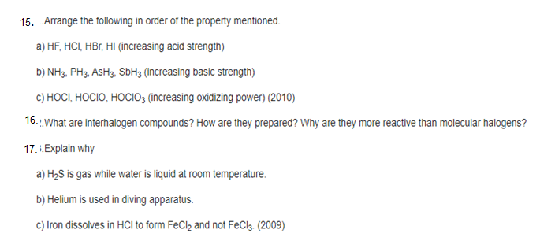
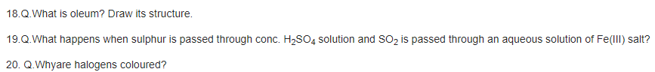
21. Justify the placement of O, S, Se, Te and Po in the same group of the periodic table in terms of electronic configuration, oxidation state and hydride formation.
22. Why is dioxygen a gas but sulphur a solid?
22. Knowing the electron gain enthalpy values for O → O– and O → O2– as –141 and 702 kJ mol–1 respectively, how can you account for the formation of a large number of oxides having O2– species and not O–? (Hint: Consider lattice energy factor in the formation of compounds).
23. Which aerosols deplete ozone?
24. Describe the manufacture of H2SO4 by contact process?
25. How is SO2 an air pollutant?
26. Why are halogens strong oxidising agents?
27. Explain why fluorine forms only one oxoacid, HOF.
28. Explain why inspite of nearly the same electronegativity, oxygen forms hydrogen bonding while chlorine does not.
29. Write two uses of ClO2.
30. Why are halogens coloured?
31. Write the reactions of F2 and Cl2 with water.
32. How can you prepare Cl2 from HCl and HCl from Cl2? Write reactions only.
33. What inspired N. Bartlett for carrying out reaction between Xe and PtF6?
34. Arrange the following in the order of property indicated for each set:
(i) F2, Cl2, Br2, I2 - increasing bond dissociation enthalpy.
(ii) HF, HCl, HBr, HI - increasing acid strength.
35. Which one of the following does not exist?
(i) XeOF4
(ii) NeF2
(iii) XeF2
(iv) XeF6
